Algeria

## Political Stability Estimate Data

The data set shows the political stability estimate of the country each year.

## # A tibble: 19 x 5  
## country iso3c date stability stabilityCategory4   
## <chr> <chr> <dbl> <dbl> <chr>   
## 1 Algeria DZA 1996 -1.78 highly unstable   
## 2 Algeria DZA 1998 -1.88 highly unstable   
## 3 Algeria DZA 2000 -1.43 highly unstable   
## 4 Algeria DZA 2002 -1.63 highly unstable   
## 5 Algeria DZA 2003 -1.75 highly unstable   
## 6 Algeria DZA 2004 -1.36 highly unstable   
## 7 Algeria DZA 2005 -0.915 moderately unstable  
## 8 Algeria DZA 2006 -1.13 highly unstable   
## 9 Algeria DZA 2007 -1.15 highly unstable   
## 10 Algeria DZA 2008 -1.09 highly unstable   
## 11 Algeria DZA 2009 -1.20 highly unstable   
## 12 Algeria DZA 2010 -1.26 highly unstable   
## 13 Algeria DZA 2011 -1.36 highly unstable   
## 14 Algeria DZA 2012 -1.33 highly unstable   
## 15 Algeria DZA 2013 -1.20 highly unstable   
## 16 Algeria DZA 2014 -1.19 highly unstable   
## 17 Algeria DZA 2015 -1.09 highly unstable   
## 18 Algeria DZA 2016 -1.10 highly unstable   
## 19 Algeria DZA 2017 -0.960 moderately unstable

## Political Stability Estimate Plot

The plot shows the trends of stabilization and destabilization for the each country.

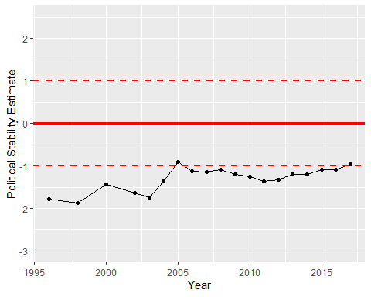

Political Stability Trend